**A Consolidated List of Links showing Participations/Involvement of faculty Members of the College in various activities:**

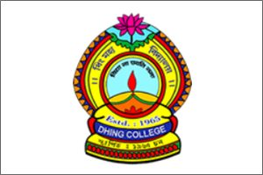

|  |  |
| --- | --- |
| **Name & Department** | **Link in web portal: www.dhingcollege.in** |
| Principal | <http://dhingcollege.in/principal/principal_CV.pdf> |
| Assamese | <http://dhingcollege.in/department_section.php?dept_id=22> |
| English | <http://dhingcollege.in/department_section.php?dept_id=23> |
| Bengali | <http://dhingcollege.in/department_section.php?dept_id=24> |
| Economics | <http://dhingcollege.in/department_section.php?dept_id=25> |
| Education | <http://dhingcollege.in/department_section.php?dept_id=26> |
| Political Science | <http://dhingcollege.in/department_section.php?dept_id=27> |
| Geography | <http://dhingcollege.in/department_section.php?dept_id=28> |
| History | <http://dhingcollege.in/department_section.php?dept_id=29> |
| Physics | <http://dhingcollege.in/department_section.php?dept_id=30> |
| Chemistry | <http://dhingcollege.in/department_section.php?dept_id=31> |
| Botany | <http://dhingcollege.in/department_section.php?dept_id=32> |
| Zoology | <http://dhingcollege.in/department_section.php?dept_id=33> |
| Mathematics | <http://dhingcollege.in/department_section.php?dept_id=34> |
| Commerce | <http://dhingcollege.in/department_section.php?dept_id=35> |

Certified that the above links are verified by the IQAC Cell and information provided in the links is found correct based on data submitted to IQAC and web portal.

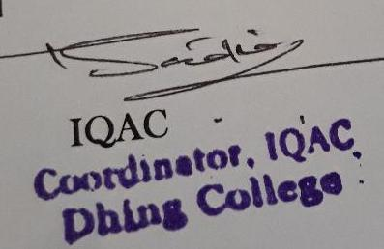

**Coordinator,IQAC**